Movie Makers Basics
Movie Maker allows you to import pictures, videos, and music. Once you have your media in the program, you can then make edits, trim music, add effects, and make transitions from one slide to the next.
This packet give some BASIC information. For more help, Google your question or ask Mrs. Galbreath/a classmate for help.
To Start a Project:
*If you are bringing in pictures/videos/or slides from Powerpoint, you need to get that information first. The following instructions will explain the best way to save your pictures from the Internet or from Powerpoint. I will also go over this in class.
Internet pictures:
Remember to write down the site url (web address) for your bibliography/works cited page at the end of your movie. You must give credit where credit is due! 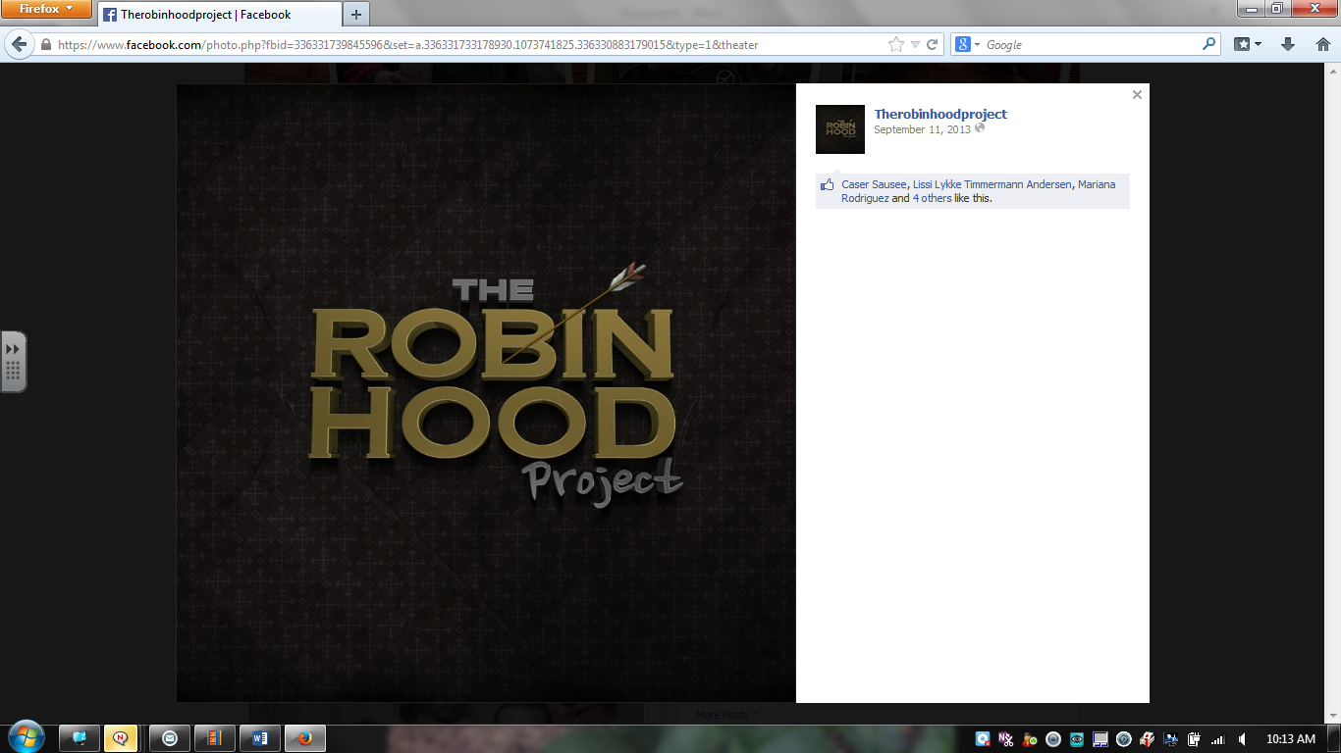 https://www.facebook.com/therobinhoodproject
Notice the citation
Once you have found the picture you want to use, right click on the image. You should see a “Save Picture/Image As” option.
Select “Save Picture/Image As” and then find a good location to save all your images for this movie. I recommend HIGHLY your server documents. Find the folder with your name on it. Double click that folder and then save to the MY PICTURES folder. That way they are all grouped together in one place. : )
Converting a Powerpoint slide to a .jpg file to upload to Movie Maker as a picture
*If you want to make a good informational slide, I highly recommend making it in Powerpoint and then bringing it into your Movie Maker file. These instructions will go over how to do that.
-Once you have created your slide, and edited it (you can’t change it after you convert it to .jpg). Go to FILE in the upper left corner and click SAVE AS.
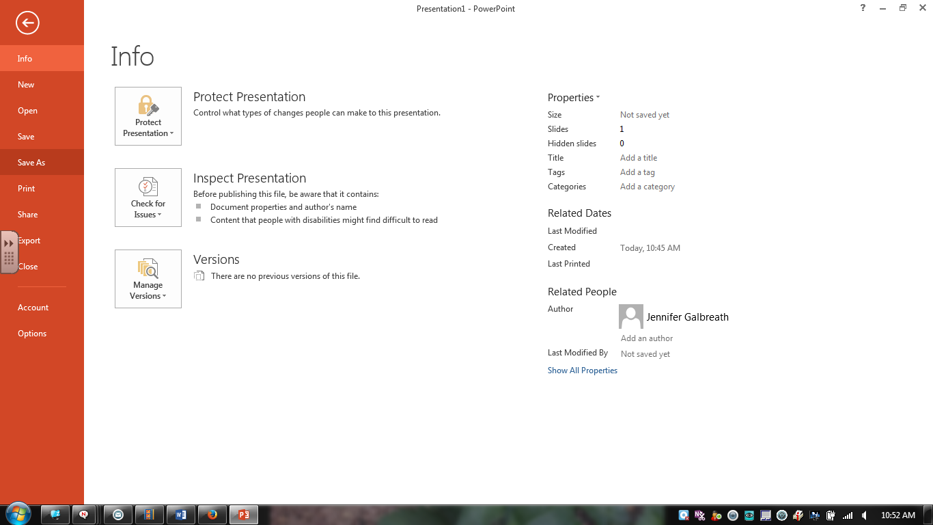
Once you click SAVE AS
Select BROWSE
You will then see the next image
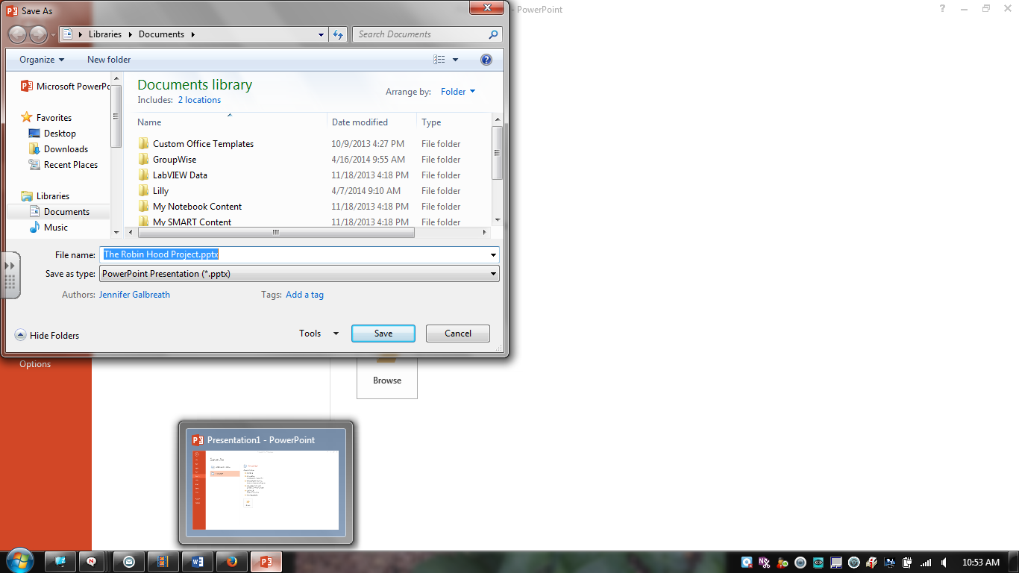
Name your picture (something other than the name it gives you)
Then select the drop down menu beneath where it asks you to name the file. That menu should say Powerpoint right now. We are going to change it to .jpg here, so you can bring it into Movie Maker.
SEE THE NEXT PICTURE
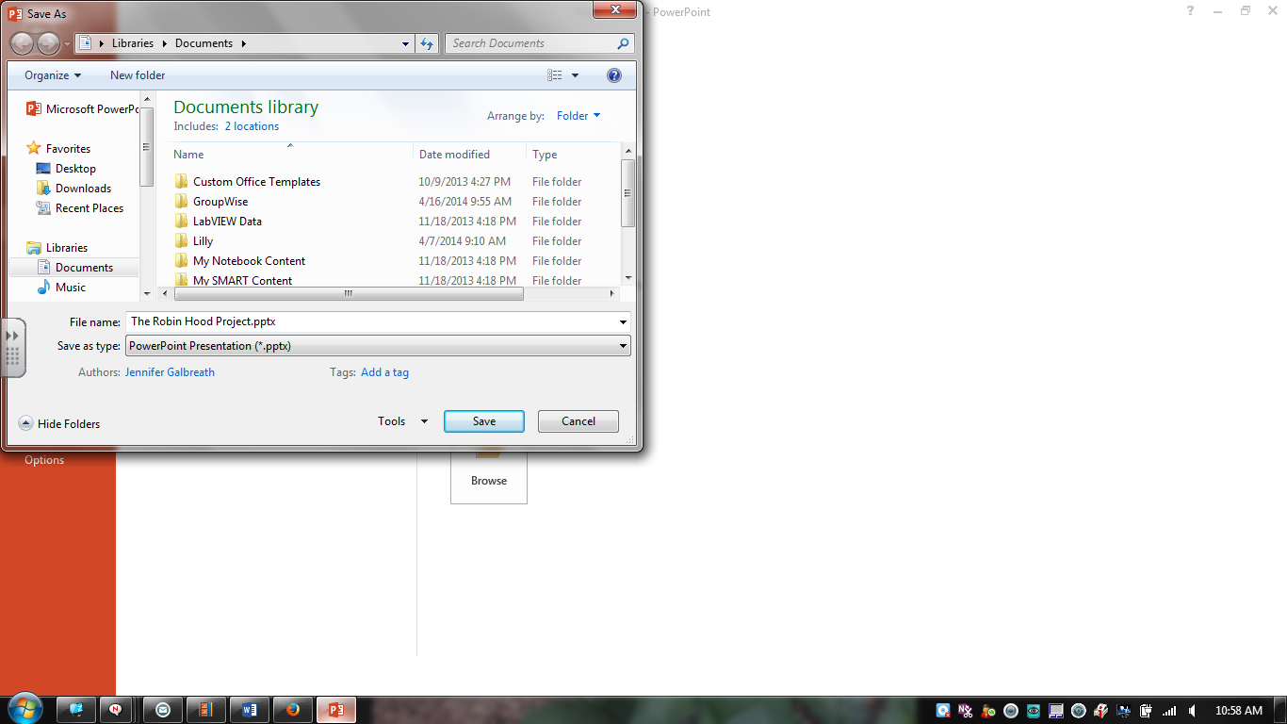
Click this menu to get a list of conversion options. See next picture
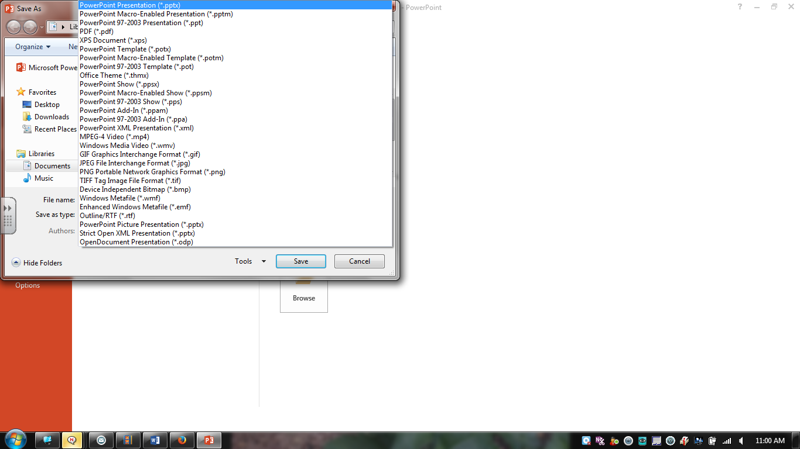
Select the one that says JPEG File Interchange Format (.jpg)
DON’T HIT SAVE YET---THE NEXT STEP IS VERY IMPORTANT!!!!
You need to tell the computer WHERE to save them here, so select that same folder from the file with your name on it and then PICTURES:
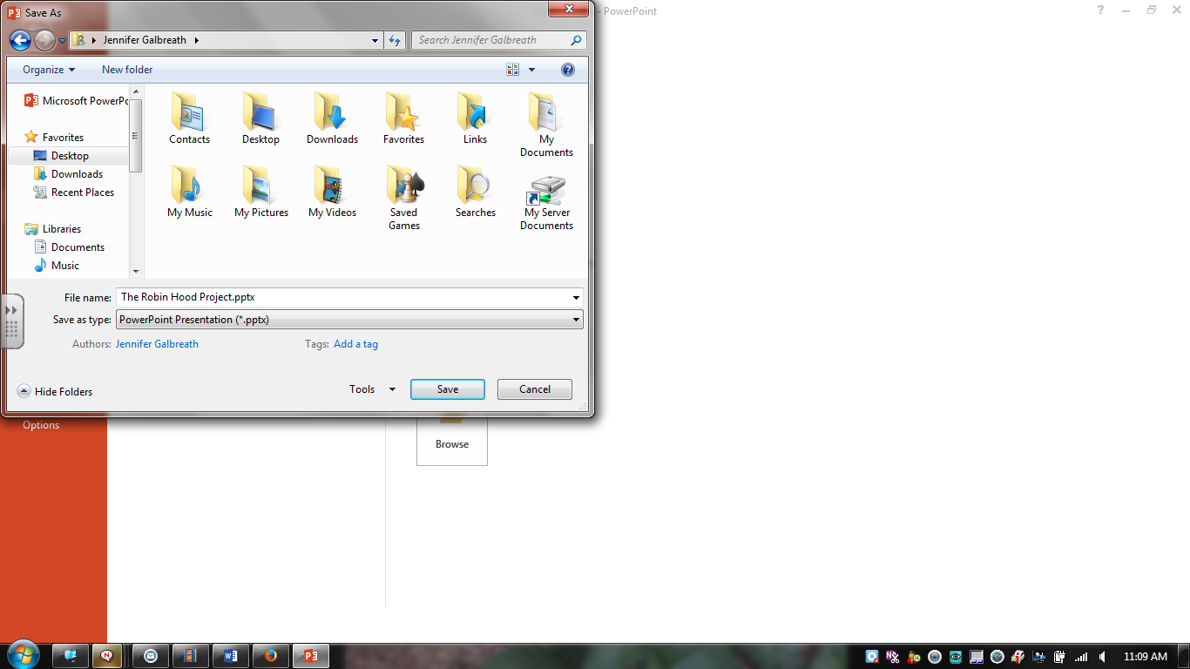

It will then ask you which files you want to convert. Select ALL SLIDES
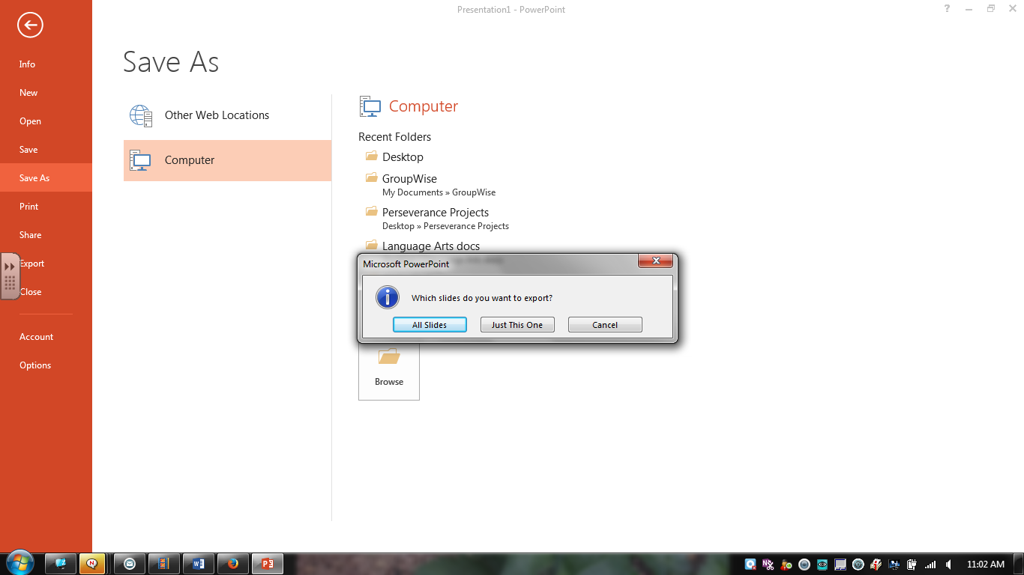
You will then receive a message that all slides have been converted and WHERE they were saved. Make sure you look at WHERE they were saved, so you can go find them.
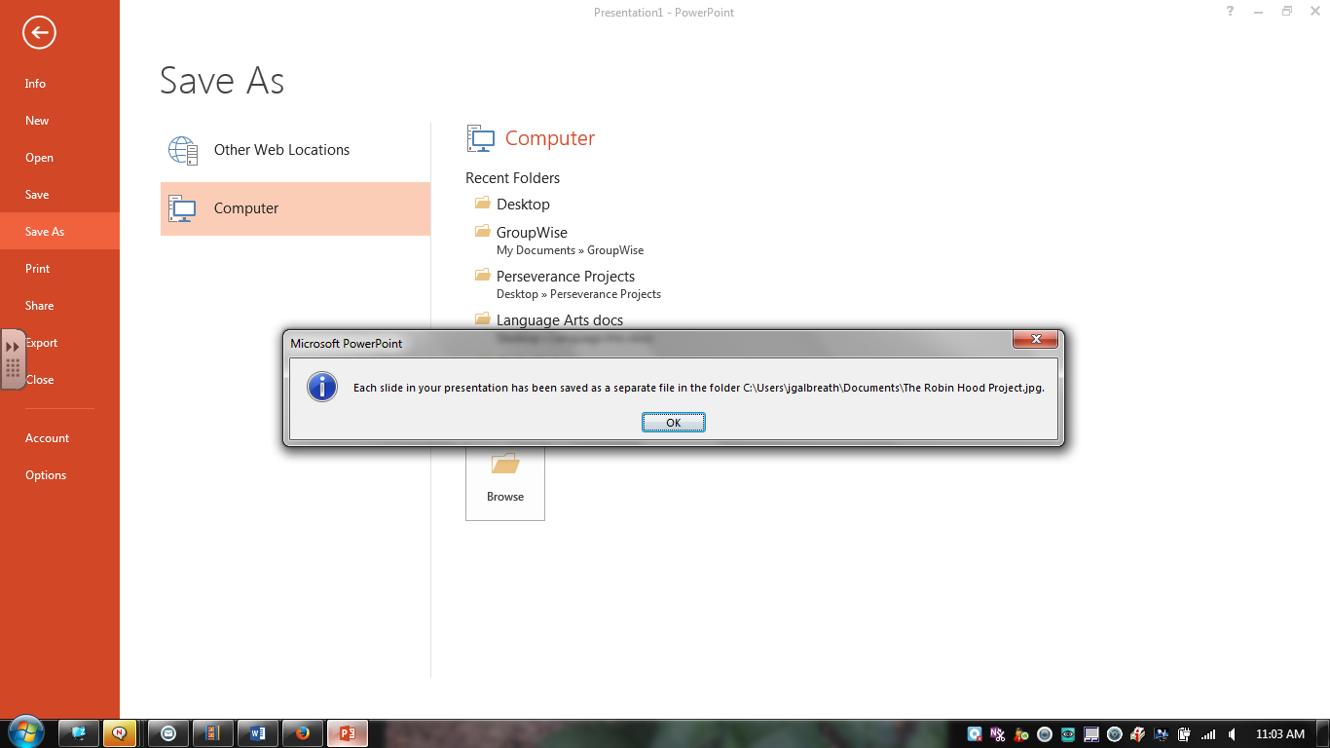
Where they are saved comes at the end of this message!
These slides give basic information about how to create a movie in Movie Maker:
Now that we have some pictures/slides, I will show you how to bring them into Movie Maker.
1st:
Click on Add Videos/Photos:
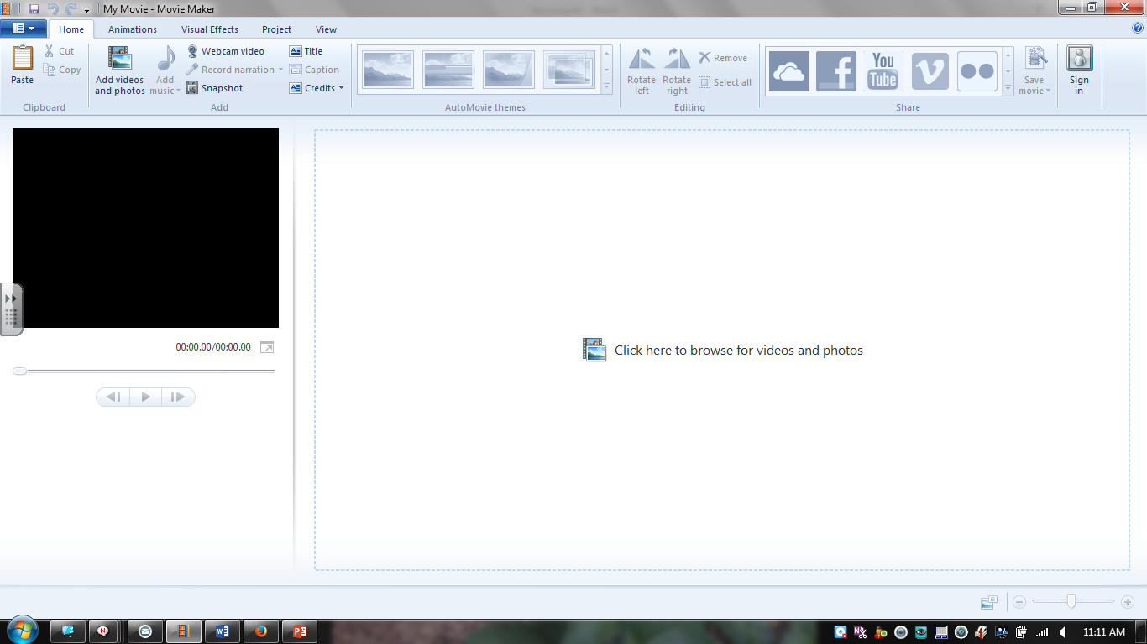

Then, find the first photo you want to use (remember, they should be in the file with your name and then under My Pictures).
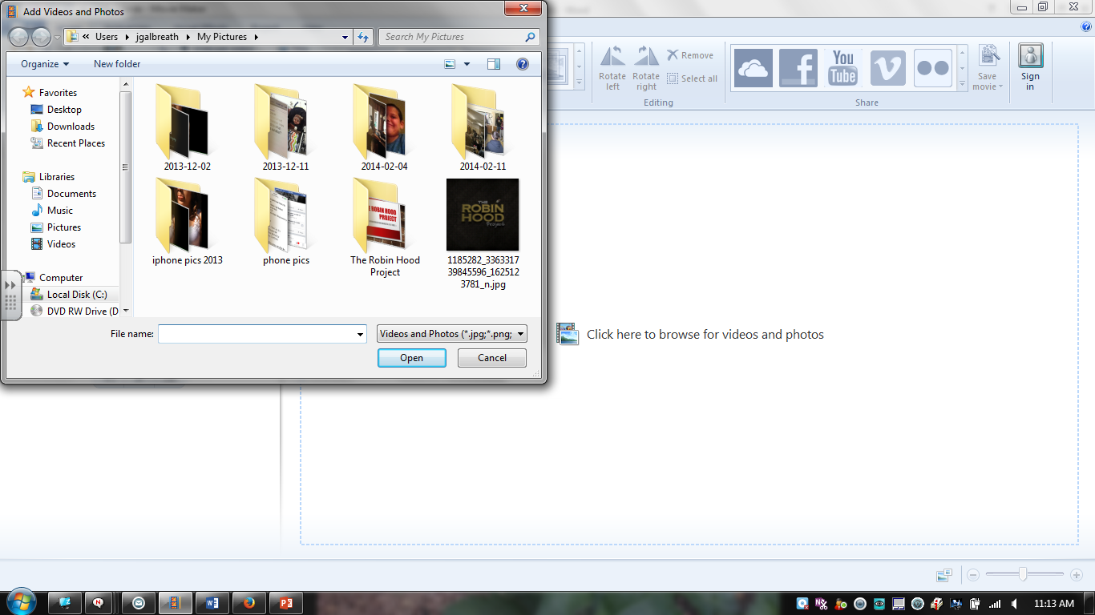

Once you double click the picture, it will show up in your Storyboard. The storyboard is the frames for your movie, placed in order, so you can see what the movie will look like as a whole. It can be found HERE:
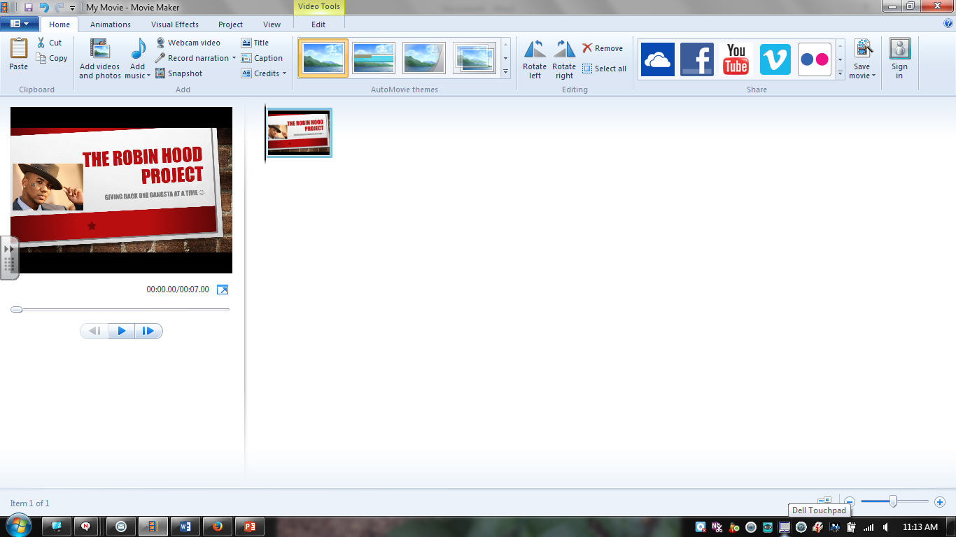
You can continue to add as many picture slides as you would like and then you can make edits, add transitions, and music once all of your pictures are in the storyboard.

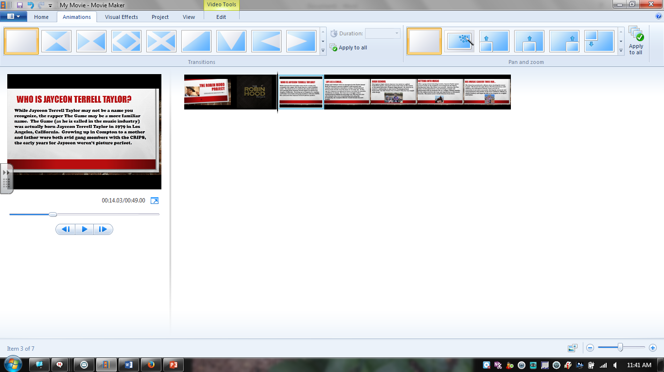
Once you have all your pictures into the storyboard, you can play around with the animations by selecting different animations for each picture or the same ones throughout. Check them first, because some make the slide blurry and we won’t be able to read it.

You can also create Captions for slides (For example, if you have a picture and you want words to come across the screen when that picture is on display).
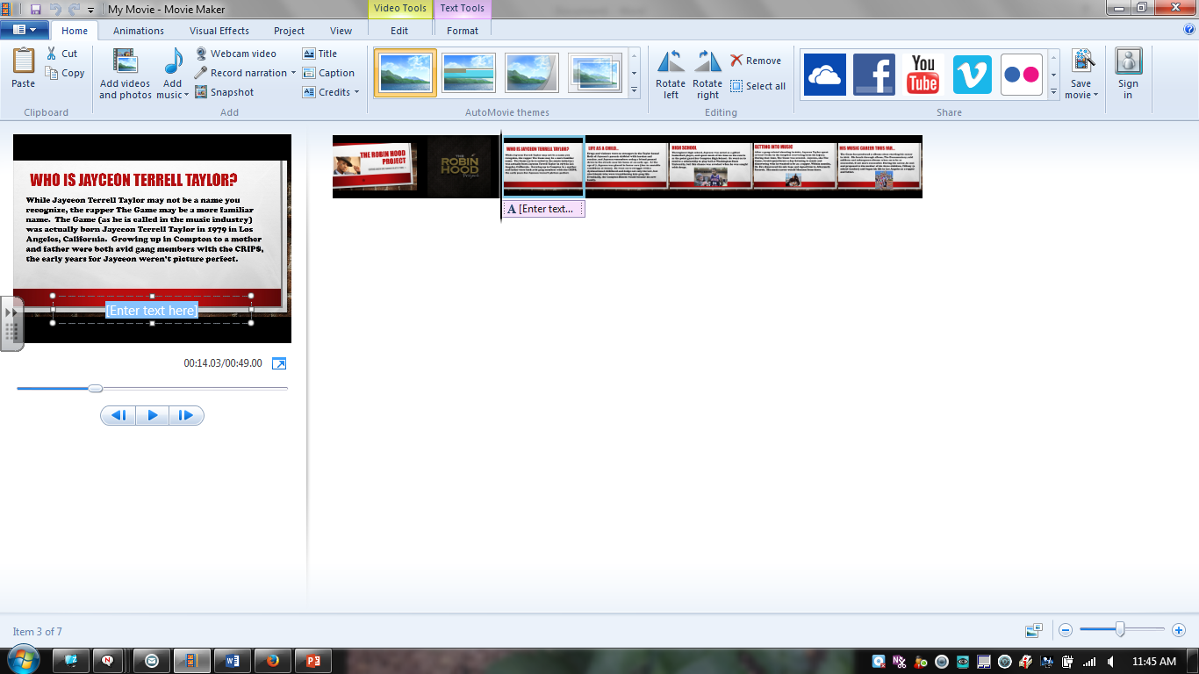
Be sure to select the picture you want the caption for BEFORE you hit Caption…or you’ll have to move it later.

You can also add music to your movie. Remember, I have a list of .mp3 songs you can select from (seen at the end of this document). If you don’t see one you like, ask me, I may have it. You have to use .mp3 files for music in Movie Maker.

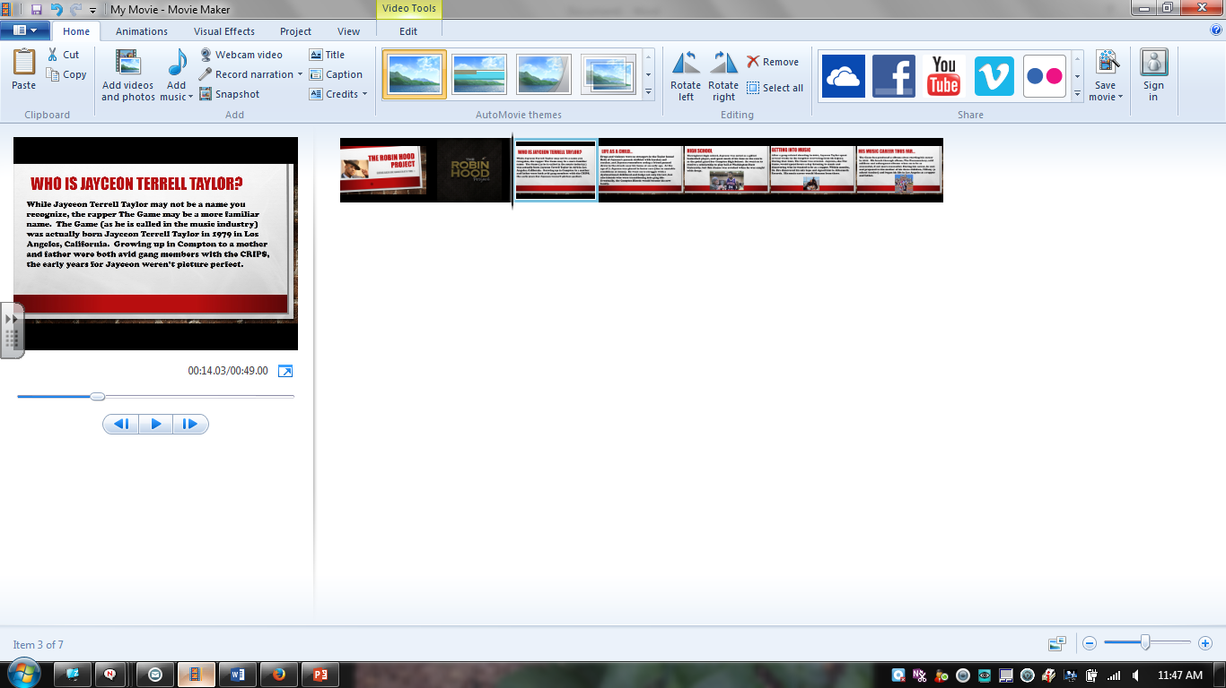

I will help get the song onto your computer, but here is how you bring it into Movie Maker. Click on Add Music and then select the song you want. Once you select it, you will see a green box appear on your Storyboard. That is your song! You can clip the song and cut it into parts, if you want it to play during certain sections of your movie. If you are interested in learning how to do this, let me know.
